1. Stadium Management

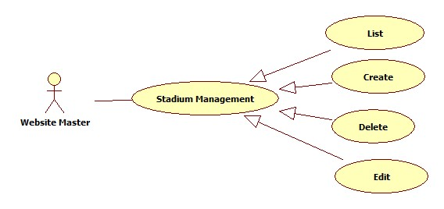

* 1. Stadium View Management

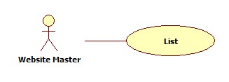

|  |  |  |  |  |
| --- | --- | --- | --- | --- |
| **USE CASE-n SPECIFICATION** | | | | |
| **Use-case No.** | <UC001> | **Use-case Version** | | <1.0> |
| **Use-case Name** | List Stadium | | | |
| **Author** | KhánhNQ | | | |
| **Date** | 12/02/2014 | **Priority** | High | |
| **Actor:**  Website Master  **Summary:**  This use case describe how to see list of stadium  **Goal:**  List all Stadium in Website  **Triggers:**  Actor go to Stadium Management page  **Preconditions:**  N/A  **Post-conditions:**  N/A  **Main Success Scenario:**   |  |  |  | | --- | --- | --- | | Step | Actor Action | System Response | | 1 |  | Display list of stadium |   **Alternative Scenario:**  N/A  **Exceptions:**  N/A  **Relationships:**  N/A  **Business Rules:**  N/A | | | | |

* 1. Stadium Create Management

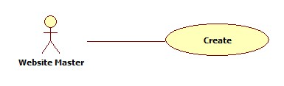

|  |  |  |  |  |
| --- | --- | --- | --- | --- |
| **USE CASE-n SPECIFICATION** | | | | |
| **Use-case No.** | <UC001> | **Use-case Version** | | <1.0> |
| **Use-case Name** | Create Stadium | | | |
| **Author** | KhánhNQ | | | |
| **Date** | 12/02/2014 | **Priority** | High | |
| **Actor:**  Website Master  **Summary:**  This use case describe how to Create stadium in website  **Goal:**  Create Stadium in Website  **Triggers:**  Actor click Create button Create stadium in website  **Preconditions:**  N/A  **Post-conditions:**  N/A  **Main Success Scenario:**   |  |  |  | | --- | --- | --- | | Step | Actor Action | System Response | | 1 | Click on Create to create a stadium | The system will respond to Create stadium page | | 2 | Enter information of stadium. Click on Create button to finish | The system will create new Stadium in database. |   **Alternative Scenario:**     |  |  | | --- | --- | | Actor Action | System Response | | Click on Cancel button to cancel | System will transfer to Stadium Management page |   **Exceptions:**  N/A  **Relationships:**  N/A  **Business Rules:**  N/A | | | | |

* 1. Stadium Edit Management

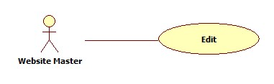

|  |  |  |  |  |
| --- | --- | --- | --- | --- |
| **USE CASE-n SPECIFICATION** | | | | |
| **Use-case No.** | <UC001> | **Use-case Version** | | <1.0> |
| **Use-case Name** | Edit Stadium | | | |
| **Author** | KhánhNQ | | | |
| **Date** | 12/02/2014 | **Priority** | High | |
| **Actor:**  Website Master  **Summary:**  This use case describe how to edit a stadium  **Goal:**  View and change stadium information  **Triggers:**  Actor click on stadium in list of stadium  **Preconditions:**  N/A  **Post-conditions:**  N/A  **Main Success Scenario:**   |  |  |  | | --- | --- | --- | | Step | Actor Action | System Response | | 1 | Click on Stadium that actor want to edit | Display stadium information | | 2 | Enter stadium information  Click on Save button to save information | Display successful message | |  |  |  |   **Alternative Scenario:**     |  |  | | --- | --- | | Actor Action | System Response | | Click on Cancel button to cancel | System will transfer to Stadium Management page |   **Exceptions:**  N/A  **Relationships:**  N/A  **Business Rules:**  N/A | | | | |

* 1. Deactivate Stadium

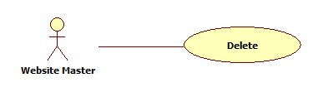

|  |  |  |  |  |
| --- | --- | --- | --- | --- |
| **USE CASE-n SPECIFICATION** | | | | |
| **Use-case No.** | <UC001> | **Use-case Version** | | <1.0> |
| **Use-case Name** | Deactivate Stadium | | | |
| **Author** | KhánhNQ | | | |
| **Date** | 12/02/2014 | **Priority** | High | |
| **Actor:**  Website Master  **Summary:**  This use case describe how to deactivate stadium in website  **Goal:**  Deactivate a stadium in system  **Triggers:**  Actor click on Deactivate button to de-active the stadium in website  **Preconditions:**  N/A  **Post-conditions:**  N/A  **Main Success Scenario:**   |  |  |  | | --- | --- | --- | | Step | Actor Action | System Response | | 1 | Click on Deactivate button of stadium | Display confirmation message | | 2 | Click on OK button | Display successful message |   **Alternative Scenario:**     |  |  | | --- | --- | | Actor Action | System Response | | Click on Cancel button to cancel | Hide confirmation message |   **Exceptions:**  N/A  **Relationships:**  N/A  **Business Rules:**  N/A | | | | |

* 1. Activate Stadium

|  |  |  |  |  |
| --- | --- | --- | --- | --- |
| **USE CASE-n SPECIFICATION** | | | | |
| **Use-case No.** | <UC001> | **Use-case Version** | | <1.0> |
| **Use-case Name** | Activate Stadium | | | |
| **Author** | KhánhNQ | | | |
| **Date** | 12/02/2014 | **Priority** | High | |
| **Actor:**  Website Master  **Summary:**  This use case describe how to activate stadium in website  **Goal:**  Activate a stadium in system  **Triggers:**  Actor click on Activate button to active the stadium in website  **Preconditions:**  N/A  **Post-conditions:**  N/A  **Main Success Scenario:**   |  |  |  | | --- | --- | --- | | Step | Actor Action | System Response | | 1 | Click on Activate button of stadium | Display confirmation message | | 2 | Click on OK button | Display successful message |   **Alternative Scenario:**     |  |  | | --- | --- | | Actor Action | System Response | | Click on Cancel button to cancel | Hide confirmation message |   **Exceptions:**  N/A  **Relationships:**  N/A  **Business Rules:**  N/A | | | | |

1. User's Level System Management

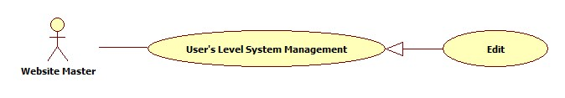

|  |  |  |  |  |
| --- | --- | --- | --- | --- |
| **USE CASE-n SPECIFICATION** | | | | |
| **Use-case No.** | <UC001> | **Use-case Version** | | <1.0> |
| **Use-case Name** | User's Level System Management | | | |
| **Author** | KhánhNQ | | | |
| **Date** | 12/02/2014 | **Priority** | High | |
| **Actor:**  Website Master  **Summary:**  This use case describe the level of user in this system, correlative with user ability  **Goal:**  Can set level to the user account  **Triggers:**  Actor use click on Edit button in page User Information.  **Preconditions:**  N/A  **Post-conditions:**    **Main Success Scenario:**   |  |  |  | | --- | --- | --- | | Step | Actor Action | System Response | | 1 | Click on Edit button in User Information | The system will show page of User Information | | 2 | Fill the level correlative with user ‘s point |  | | 3 | Click Save to save rank | The system will go back to page of User Information |   **Alternative Scenario:**   |  |  | | --- | --- | | Actor Action | System Response | | Click on Cancel button to cancel | System will go back to page of User Information |   **Exceptions:**  N/A  **Relationships:**  N/A  **Business Rules:**  N/A | | | | |